**University of Petroleum and Energy Studies** School of Computer Science Department of Cybernetics



Graphics & Animation Tools

# LAB FILE

**(Session: 2020-2021)**

Course: B. Tech with Specialization in Open Source and Open Standards

Batch: 2017-2021

Semester: VIIth

**Submitted To: -**

Dr. Durgansh Sharma Assistant Professor Department of Cybernetics

**Submitted By: -**

Pranay Gaur

Roll No: R100217051 SAP ID: 500062466

## VIVA-1 GAT

1. **Aim:** Create a Mobile Phone using GIMP

## Steps:

* 1. Open GIMP.
  2. Inside gimp, create a new layer with white background (1080x1080 px).
  3. Open an image of smart phone as layers in GIMP and create a new transparent layer to draw boundaries.
  4. Use the ‘Paths tool’ over the image and start selection boundaries and layout of the

image.

* 1. After selection of layout/ boundaries, go to ‘Select’, choose ‘From Path’ option and

your path will be selected.

* 1. After path is selected click on ‘bucket fill tool’ from the toolbar and color the smartphone with your desired color.
  2. Repeat step 3,4,5 for creating the base, front and screen of the smart phone.
  3. Structure of smartphone is complete, now go to ‘Text tool’ and write name of the

brand that you want for your phone.

* 1. Use your creativity to style your text and when you feel it’s good, then place is at the

desired location.

* 1. For adding the app icons and notification panel on top, use rectangle selection tool and ellipse tool for creating rectangle icons and circular icons.
  2. For creating battery percentage on top right, go to ‘Text tool’ and write number, adjust size and location of it.
  3. Additional: For creating time widget, cut the image and place it on the desired location

i.e. center.

## Output:

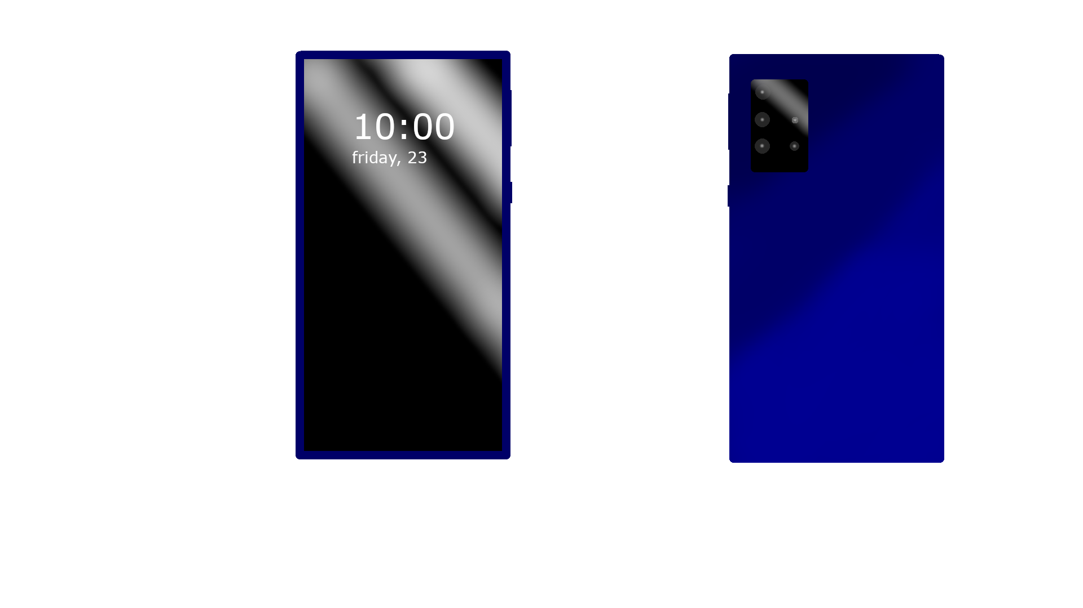

1. **Aim:** Create a fruit basket or set of fruits using blender.

## Steps:

* 1. Open Blender, and clear everything from the interface which are already there.
  2. For apples, take the sphere from the mesh and give it a groove from above so, that it looks like the upper portion of apple. Now, put some dots on the apple to give it more realistic look.
  3. Now, take the upper portion of apple and extrude it a bit to give the shape of twig which is attached with the apple.
  4. Extrude the bottom of the surface around 1.5 pts and give it shape of base of the apple top.
  5. Add a few details in the model of basket to give it a realistic approach in better ways.
  6. Now, go to shading and then random and fill your selected area with random colors.
  7. Add camera and point surface light for rendering of our model.
  8. Go to file and save it as your name and render a few pictures for the display.

**Output:**

